016 Gulp - optimizing css

Gulp Kata List – Blog Page

[Gulp Kata List on GitHub](https://github.com/robertdunaway/katas-gulp)

# Duration

5 minutes

# Brief

In this kata we will optimize css files.

### For More Information

BING/GOOGLE: “Gulp optimize css”

Book: <http://www.amazon.com/Gulp-Quick-guide-getting-running/dp/151468960X>

# Instructions

Get tutorial folder or the entire katas-angular2 repo.

Open the [before/*.sln] file and execute the kata.

Feel free to execute this kata multiple times because repetition creates motor memory.

# Github

* Before (start kata with this)
  + https://github.com/robertdunaway/katas-gulp/tree/master/016%20Gulp%20-%20optimizing%20css/before
* After
  + https://github.com/robertdunaway/katas-gulp/tree/master/016%20Gulp%20-%20optimizing%20css/after

# Kata

After copying all src files to wwwroot, optimize the css.

# Review

Install the npm plugins we need. The gulp, gulp-rename, run-sequence, and gulp-sourcemaps have already been installed.

npm install gulp-minify-css --save-dev

References will now look like this

var gulp = require('gulp')

, runSequence = require('run-sequence')

, rename = require('gulp-rename')

, sourcemaps = require('gulp-sourcemaps')

, minifycss = require('gulp-minify-css');

Create the new minifyhtml task and add it to the default task.

gulp.task('minifycss', function () {

return gulp.src(['wwwroot/**/*.css', '!wwwroot/**/*.min.css'], { base: 'wwwroot/./' })

.pipe(sourcemaps.init())

.pipe(minifycss())

.pipe(rename({

extname: '.min.css'

}))

.pipe(sourcemaps.write('./'))

.pipe(gulp.dest('wwwroot/./'));

});

Check out your newly optimized html files.

Before

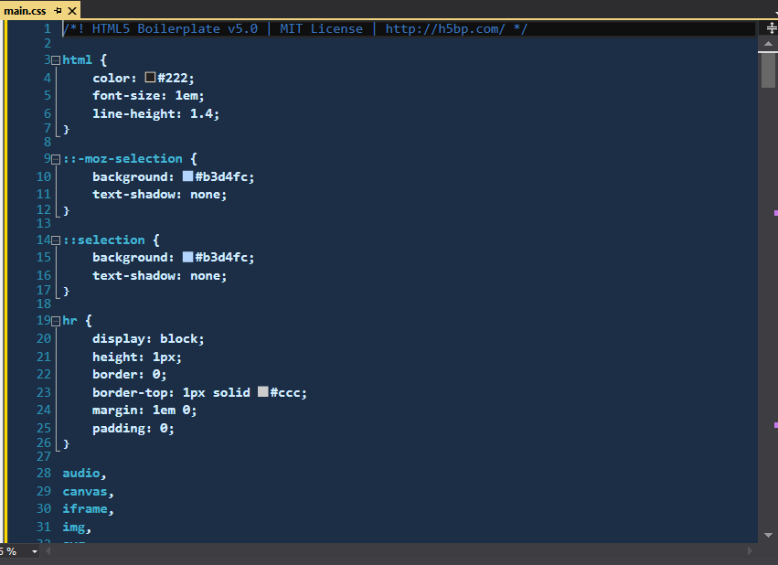

After

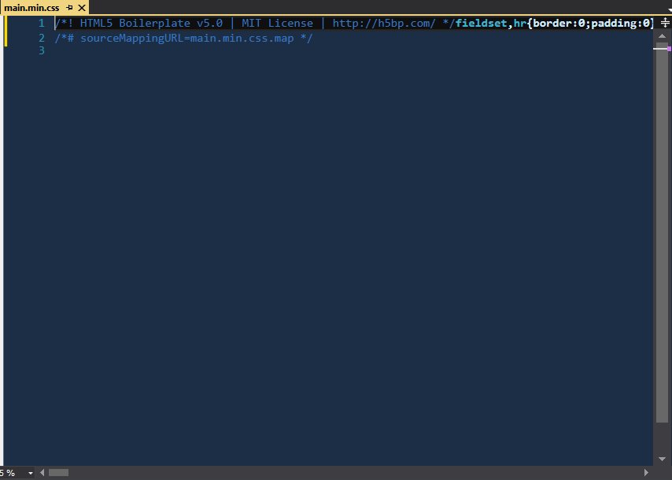

# Next

Take a few minutes and imagine more examples.